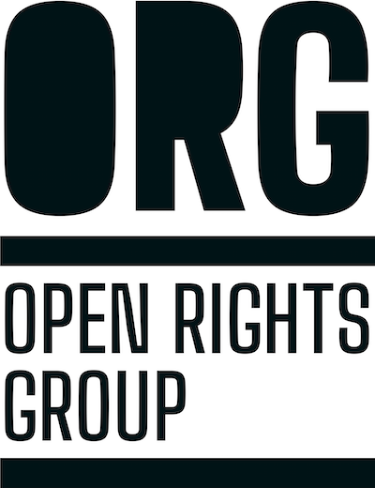 | Pre-Crime Programme Manager  Job Application Form  January 2026

Instructions
- Fill in your candidate details on page 2.
- Please complete the interview question on page 3 in your own words.
While candidates are welcome to use AI tools for spell checking or idea generation, we have found that answers copied and pasted from generative AI tools tend to be generic and perform less well than genuine human responses.
- Write your answers to the three eligibility and access questions on page 4.
- Once complete, send the completed document along with your CV to recruitment@openrightsgroup.org with the subject header “Pre-Crime Programme Manager Application”, before 9am on Monday 2 February 2026 (applications received after the deadline will not be considered).

Candidate Details

Full name:

Email address:

Phone number:

Interview Question
Please outline why you want to lead our Pre-Crime programme and what you would bring to the role. Please limit your answer to 300-400 words.
Candidate Answer:

Eligibility and Access Questions
- Are you eligible to work in the UK? (please delete the answers that do not apply to you)
  - Yes, I’m a UK citizen or am otherwise eligible to work in the UK
  - Yes, but I need visa sponsorship
  - No

- We hope to make job offers in the last week of February. If successful, when would you available to start work?
Note: an early March start date would be ideal, in order to enable a smooth handover from the current Pre-Crime Programme Manager.
If your notice period or other factors would prevent you from starting in early March, but you think you would be excellent for the role, we are open to considering alternative options for handover (feel free to indicate what may be possible for you in your answer).
Candidate Answer:

- Please let us know about any additional support or adjustments you might require to make this recruitment process accessible for you. If you have any questions about this or want to discuss anything in more detail, please don't hesitate to contact us at recruitment@openrightsgroup.org.
Candidate Answer:

Once complete, send the completed document along with your CV to recruitment@openrightsgroup.org with the subject header “Pre-Crime Programme Manager Application”, before 9am on Monday 2 February 2026 (applications received after the deadline will not be considered).

